**52 - PHILIPPINE MISSION – MARCH 2003 TO FEBRUARY 2005**

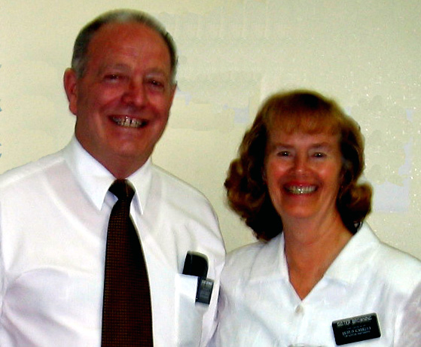When we received our mission call on Christmas Eve 2002, it said we would go to the Angeles Philippine Mission and be proselyting in the Tagalong language. We were so surprised. Because of our health, our nutritionist, Nancy Litchford, told us that we would not go foreign. I had high blood pressure and fibromyalgia and Ken had yeast problems for which he had to be on a special diet and take lots of supplements. When the brother, from the mission department called, he said “I bet you didn’t expect to go on a foreign mission.” I said “No, we didn’t.” He then told me that all senior couples want to go on English speaking missions as they don’t want to have to learn a foreign language. He told me that they don’t have enough places (United States, Canada and England) to send all these couples to, and he said: “other countries need you senior couples. He told us that we would have a tutor call us three times a week to teach us Tagalong. This tutor’s name was Elder Black. He had been a missionary in the Philippines and was now going to BYU and was working for the church as a part-time job to help make money for his studies. We were told to go to BYU to pick up our manuals and other materials, which we did. We also got phone equipment so that Ken and I could both hear him and use our hands to write down what he told us. Learning the language was very hard for Ken, but I was able to memorize enough words to be able to bear my testimony and pray in Tagalong. We had told our children that we would come visit them and spend a few days with each of them before going on our mission. We had to take our books along, when we went to visit our families, and we had a schedule of which day and time he would call us. Our sons were excited that we were going foreign because all of them had – Mike to Norway, David to France and Belgium, Scott to Venezuela, and Jeff to Mexico City, Mexico.

We were able to talk to our family physician, Dr. Gary Lee, who gave us a letter telling, the authorities at the airports, that we needed these medicines and supplements for our health and we would be gone for two years. We bought and packed one suitcase with our two year’s supply of supplements and my three-month supply of blood pressure medication.

I **will continue with my Homecoming talk since it gives a summary of our mission.**

**TALK FOR OUR HOMECOMING MEETING -**

My, what an experience we have had with going on a full-time mission. We are so thankful for this opportunity and blessing. It has been hard and challenging at times, just like anything we do in life, that is good and rewarding, but it was a privilege to serve our Heavenly Father and his children in the Philippines.

When our stake president, President Sanders, was interviewing me prior to coming on our mission, he asked if I felt worthy to represent our Savior, Jesus Christ. I became emotional and said “I hope so, I do love him. Now that our mission is over, I hope that our Savior was pleased with what we did. It was a great privilege to represent Him.

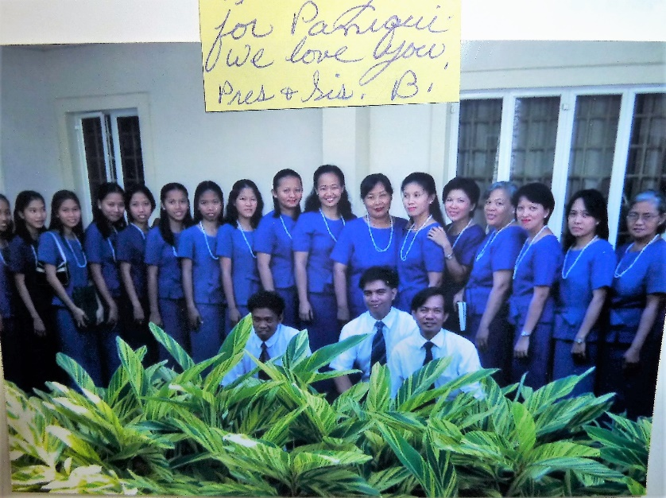 I have always loved the song “Called to Serve”. I loved to sing it in Primary with the children, when I was serving in the Primary, and when it was added to our Hymn book, I was excited. As we joined, with all the other missionaries at our last devotional at the MTC, before leaving for our missions, and sang that beautiful missionary hymn, I could hardly sing at all because I had become so emotional. “Called to serve him, Heavenly King of Glory, chosen heir to witness for his name, far and wide we tell the Father’s story, far and wide, his love proclaim.” When we arrived in the Philippines and went to our new little branch for our Sunday meetings, the branch president asked us to sit on the stand and bear our testimonies to the members. One of the hymns we sang that morning was this beautiful hymn “Called to Serve”. As I looked down at my Filipino brothers and sisters and heard them singing this hymn, and realized that Elder Browning and I were here on our missions on the other side of the world, singing this special hymn with them, again I could hardly sing. We were “called to serve our Heavenly King of Glory and chosen to witness for his name. We had come “far” to tell the Father’s story and proclaim his love.” This was the mission we had set a goal for when we were first married and for which we had hoped and prayed for all our married life. And NOW WE WERE HERE. **(This picture is of the District Choir in the Paniqui District. These were great friends of ours**)

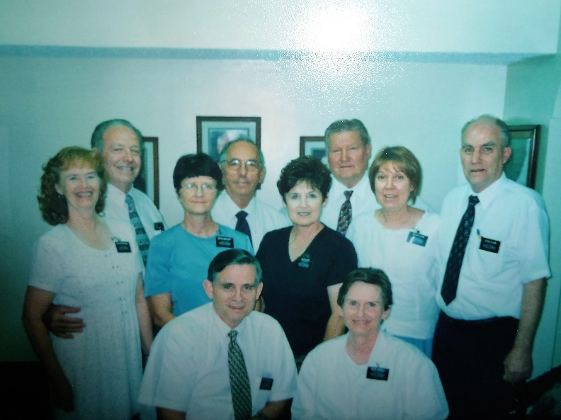 Elder & Sister Clark, our good friends who were the office couple, e-mailed us and one of the things they told us was “You will love the people. They are so friendly, hospitable, affectionate and kind. They said “When your mission is over, the office elders will have to drag you to the airport as you won’t want to leave these people.” Well, Brother. Clark, they didn’t have to drag us to the airport, as we were anxious to see our family & friends here in America, but it was really hard to leave our wonderful friends there in the Philippines. The Guimba District gave us a “farewell party” and I think I cried most of the evening thinking that I might not see them again, at least in this life.

**This picture is from left to right: Sister & Elder Browning, Sister & Elder Mcharry, Sister & Elder Hyer and Sister & Elder Clark. President & Sister Brimhall are in front**.

Small miracles took place making it possible for us to go on our mission, and small miracles took place over there also. One such miracle, in the Philippines, was with our good friends Brother Roger & Sister Heidi Silvia. They were a wonderful couple with two precious children, but after setting goal to go to the temple, Satan jumped in was trying to destroy their marriage. They knew they had to pay tithing in order to get a temple recommend, but they didn’t see how they could. He had just lost his job and they didn’t have much money to hold them over until he could get a new job. He had been trying to find a job, but hadn’t been able to. We told them that the Lord blessed us after the trial of our faith. We told them that if they paid their tithing, the Lord would bless them. They took the leap of faith and did pay their tithing and a couple of days later, while he was out looking for a job, his wife got a call for Roger to come in for an interview with a company he had applied with. She called Roger really excited; he went in for the interview and got the job.

I am so thankful for the power of prayer and for the love our Heavenly Father has for his children. Elder Browning and I would pray that we would be led and guided as to how we could help these people, and we were led and guided. We prayed for inspiration, and we were blessed with inspiration. We couldn’t have done what we did without the Lord’s help. Brother Browning is amazing. Sandi, our oldest child, used to tell everyone when she was little “My dad can fix it, my dad can do anything”. And, he can do practically anything, but he too needed the Lord’s help on our mission.

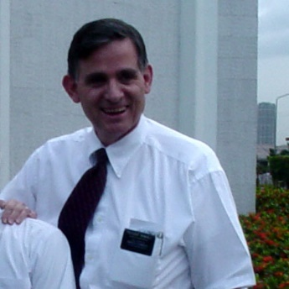

When we first met with our wonderful **mission president, President Grant Brimhall**, and his wife, we asked him what he wanted us to do and he said “Go to your area, see what needs to be fixed and fix it.” He said, “We prayed you here, so the Lord will help you.” The Lord did help us.

We learned to rely on the spirit, as we were called upon, many times at the last minute. to speak, give a lesson, lead the music, etc. – the many experiences of a missionary. Sometimes we would go to meetings or activities and find our names on the program. But as we read, studied, prayed and fasted, the Lord was always there for us and it constantly amazed us at the help he would give us. We felt the spirit with us much of the time, and when we didn’t, we knew it was because we didn’t do our part or have the right attitude.

Many times, we would be prompted to go visit someone, and sometimes to take something to them and when we arrived they would say “Thank you for coming, I was praying that you would come.” Or, “How did you know I/we needed you?” Sometimes, it was just because they were lonely and needed someone to come and visit with them, sometimes they were sick and needed a blessing, and sometimes they had serious problems.

That is the first problem we tried to “fix” was getting the brethren to go Home Teaching and the sisters to go ‘Visiting Teaching”. This wasn’t happening like it should. We felt that if the members were doing this, there wouldn’t be so many lonely, sad, unhappy people, because they would have their home teachers and visiting teachers, who were their friends and who cared about them, and they would be the ones to go there and help them. They would be the ones, who would be prompted to go visit these people. In Mosiah 18:8-9, It says that we will be “willing to bear one another’s burdens, to comfort those who stand in need of comfort, mourn with those who mourn and stand as witnesses of Christ at all times, in all things and in all places.” The members were not fulfilling these assignments and we felt that was the reason why there was only about 10% of the members attending Church. We fasted and prayed about what to do and we were soon giving H.T./V.T. workshops and firesides, in our branches and districts and throughout the mission. Sometimes we held them with the help of the young missionaries, and sometimes by ourselves. At first, we thought we could just teach them how to do H.T./V.T., teach them what to do, the importance of doing it and give some inspirational experiences to motivate them, and WE THOUGHT THEY WOULD DO IT – but it wasn’t that easy. They are a more laid-back, easy going people. They would be excited at first, but it wasn’t long until it would die down again. Many of the leaders would get H.T./V.T. organized, but it was hard for them to get the members to go. We kept praying, evaluating & changing, in the hopes that somehow, we could get them to do it. But, we didn’t feel too successful in this area. We hope we helped some.

Soon, we were given instruction, from our area president & apostle, Elder Dalen Oaks, through our mission president that President Oaks would like the couple missionaries to go to 5 less-active families from each branch and give presentations to them. He gave us a list of 7 topics which we were to develop presentations on, and he said if we were inspired to do others, that we should do it. We were having some success with that and enjoying teaching these families, especially one family – **the Corpus family**. They had one child whose name was “Joy”. They lived in our branch in Munoz. She would call me “Mrs. Universe” and smile as she said it, and we would kid each other about who was Mrs. Universe.

One evening as we were teaching them, it started to rain. They have a tin roof, so it was noisy, and they had to move in closer to us in order to hear us. It rained harder and harder and pretty soon the water started coming into their home. We decided we better close and head for home as it looked like a typhoon was on its way. Brother Corpus said he would get their boots for us to wear, but Ken told him that we had boots in the trunk of our car, and asked if he could go out and get them for us. He did this and when we went out, we were glad we had on boots as the water was so high. We were parked by one of their sewage ditches and as I walked to the car, I forgot about the ditch as I didn’t see it since the water had filled it up and overflowed. I stepped into it and the water was high so it went inside my boots. We got into the car and when I got home, I quickly showered and we poured alcohol all over my feet and legs. The water is so polluted that it is dangerous if you get it on you.

One evening, as we were leaving a home and it was raining, as I stepped out the door, **a gecko dropped off their roof and down my neck inside my blouse**. I stifled a scream, as I didn’t want to embarrass the family. I quickly ducked down a little, put my hand down my blouse, grabbed the gecko and threw it out. When we got into the car, Ken asked me what that was all about, and I told him. I was sure glad I was able to get the gecko out, before it got any further down my body.

When we first moved into our cute home in Munoz, there were geckos on the outside of the screen, and I thought they were cute and even named them, but as I saw more and more of them in our home and heard the loud noise they made, I didn’t like them so much anymore. As I would open a drawer or cupboard and one would be inside and would scurry around, I would be scared. Marlyn cleaned our cupboards, drawers and countertops at least once or twice a week, so I was glad for that and appreciate her so much. Marlyn had served a mission, and she had also been a domestic helper in Hong Cong, so she really knew how to clean, do laundry and cook very well. She was certainly a blessing to us

**With leadership training, we saw more success.** We had been doing some leadership training, but after a few months in the mission, Pres. Brimhall, under the direction of Pres. Oaks, changed our assignment, asking that we go to a branch for a month at a time to train all the priesthood and auxiliary leaders. Elder and Sister Clark, who were the office couple, were asked to help Elder & Sister Maharry and Elder Browning and I, with this, so we worked together to make a schedule. We felt this made a difference and we could see more progress. We enjoyed getting to know the members better by being with them at all their meetings and activities for a month. We would teach & train, then repeat, follow-up, encourage and praise them. We used pictures, over-head transparencies, role plays, demonstrated & used power point presentations. We taught them the importance of having presidency meetings and what we do in presidency meetings as they were not having them. We told them “If you fail to plan, you plan to fail.” Many were failing – the children or youth were bored and misbehaving because the leaders & teachers were not prepared, and many of the children & youth were not coming. After we worked with the presidencies and trained them, many became excited and they held their meetings and came prepared. Most of these good people wanted help and they appreciated it.

We met with President Gajonera, his counselors & executive committee at a PEC meeting, and they were excited. President Gajonera told us that all of his priesthood and auxiliary leaders were working hard and magnifying their callings and were visiting and reactivating. He told us that the training we had given, had really helped their branch. We were grateful that we could help and to see them so excited.

The month went by fast and we would say “goodbye” and go to the next branch. We wished we had at least 2 to 6 months with each branch as 1 month wasn’t enough, but with the Lord’s help, we were able to help them.

When we started this schedule, President & Sister Brimhall asked us to make primary our priority, and attend there every week. They asked us to teach, train and help the leaders so they could function like Primary should. They said: “Primary is where the foundation for the testimony of the children begins, and we are losing too many children and youth.” Primary, in the Philippines, had mainly been a “nursery.

The first week that we attended Paniqui 1, we went into primary. The primary president was an older sister. Primary wasn’t functioning like it should, but she was trying. She asked me to help her. She had 2 counselors, but they were not helping her, she was doing it all. I was able to give her and her counselors some training after primary, and she said “Sister, I was ready to ask to be released. I have been the primary president for 10 years. I love the children, but I was getting tired and discouraged. No one seemed to care about primary except me, and no one visited or gave us training. Now I want to stay in and I can do it right. She did do it right. We were invited to attend a district activity a few months later, and her branch had more children than any, and they were really prepared with their presentation and did so well.

One primary president said “Sister, the children want you to do “Sharing Time” and “Singing Time” because you make it fun. I told her “You and your counselors can make it “fun” also, just follow the Outline for “Sharing Time and the Sacrament Meeting Presentation”. Use the Liahona, prepare well, pray for the spirit to be with you, and be enthusiastic. Sister Brimhall said “If you’re having fun, the children are having fun too”.

President & Sister Brimhall said our second priority was to be YM & YW and we attended at least one of their Sunday meetings a month and attended mutual as often as we could. We were also to train the Relief Society and the Branch Presidency and Elder’s Quorum. Ken trained the men and I trained the women.

We also trained the district leaders, and had them help us with the trainings whenever they could. We asked these district leaders to continue to teach, train, resolve concerns and help these branch presidencies. We found that many presidencies if they were not trained, became overwhelmed and discouraged and just quit coming to church and then became inactive.

I was so thankful for the experiences, knowledge and testimony I had gained from serving, throughout my life, in various positions in the church. This helped me so much with being able to train the leaders in R.S., Y.W. & Primary in the 2 Districts and 14 Branches we served in. I was able to share experiences and give suggestions from having served in these positions, along with teaching them from the “Handbook of Instructions”. I read and studied the handbooks, for these organizations, as I didn’t want to lead any of them astray – so I learned a lot more. I was always referring to these handbooks, highlighting and underlining them. I’ve learned more about the Handbooks of Instruction than I ever knew before.

There is so much poverty over in the Philippines, and it made us sad to see so many suffer, but there was such a difference when they joined the church and remained faithful. They had hope, and they were happy even though they had trials as they trusted in the Lord. Many of our Filipino brothers & sisters would delight in telling us about their conversion and baptism and how it had blessed their lives. They spoke fondly of the missionaries who had baptized them.

We were in the Paniqui 3rd Branch in January and there is a sweet little sister in Paniqui 3, who had a stroke about a year ago. The right side of her body is affected and she can hardly walk and can’t use her right arm or hand, but she comes to church faithfully and tries to do whatever she can. She confided to me that she suffers with much pain but they can’t afford her pain medication. She says as she reads the story of “Job” in the Bible, it comforts her. She says she reads the Bible, Book of Mormon & other scriptures every day and that way she feels close to the Lord and feels his love for her. She has hope that one day, probably in the next life, she will be well and whole and if she remains faithful she will be with her family and our Savior and Heavenly Father in the Celestial Kingdom. This sweet sister is only 42 years old.

We had many experiences we could tell you about. Elder Browning and I did a CSP with the young missionaries in our zone of cleaning and painting hospital beds, and later going to this same hospital with our batch mates, who were the humanitarian couple missionaries, to deliver supplies and equipment, and this made it possible for us to take a girl there, who had a terrible skin disease, to get help at no charge; and also to take 4 perspective missionaries there to get their exams, x-rays and dental work, prior to going on their mission. The hospital, doctors and dentists didn’t charge us. (More about this on p. 250)

I was sad when sisters would confide their problems to me and then say “Sister, you are the only one I can trust.” This is a real problem there – the gossiping and dishonesty.

I love children and it was great being able to meet with the primary children each week. We also got close to many youth with meeting with them in YM/YW, Mutual, Youth Conference & other activities.

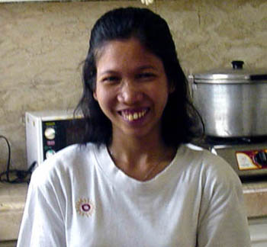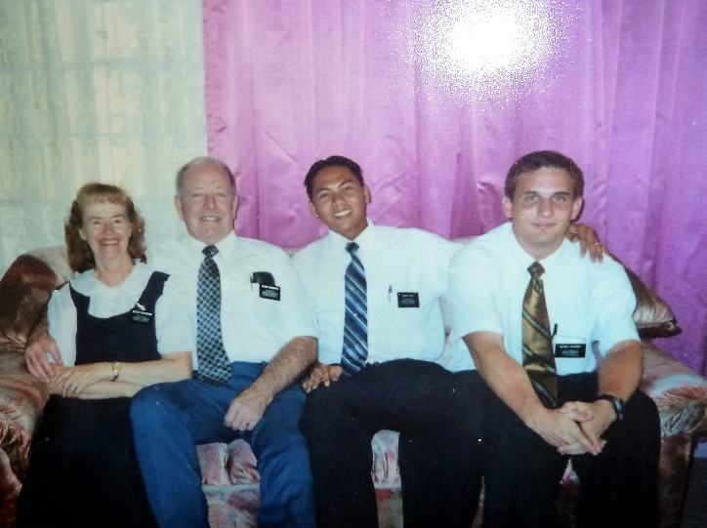**Marlyn**  - Most of you know that Brother Browning has health problems and has to watch his diet or he is in terrible pain. One of the special blessings we received, while in the Philippines, was Marlyn, our cute little “house helper”. Pres. Brimhall had suggested that we hire a house helper to do our laundry, cooking and cleaning so we could spend our full time in the work of the Lord. Elder Kendall, our zone leader and his companion, Elder Ieniora, found Marlyn for us (actually, the Lord brought her to us). Marlyn was surely a blessing to us. We have kept in touch with Marlyn through Facebook and Messenger, and I just received a message from her saying that her and her family were doing good and that she just had four more months in Kuwait until she could go back to the Philippines to her family**. (We are messaging back & forth right now. This is amazing. She is in Kuwait and I am here in Utah in the United States, and we are messaging immediately. It is October 25, 2017)**

We loved being with the young missionaries. They were so dedicated and obedient. We learned a lot from them as we met with them in district meetings and zone conference and heard them give workshops. Some of them, especially the Filipino Elders, had sad stories also, but we were proud of them for their sacrifice to come on missions when many times they were the only member in their family and didn’t receive any support from their families, and some parents disowned them for joining the church. We had the Zone Leaders, who lived close to us, over for breakfast and other meals often, and enjoyed being with them. They were dedicated, good missionaries. **Elder Daniel Hulbert** was one of them. We loved him. When we moved to the Monte Vista Ward and went to church, we saw Daniel and were so surprised and excited. They live in another ward who meets in our building. He introduced us to his wife and three children. They have four now. We invited their family to dinner and had a great time. It is fun to see their family as we pass by in the building and chat a minute or two.

We don’t have time in this meeting to tell you about these people, but maybe we could tell you some of these in a fireside and show you pictures of these wonderful people

I am so thankful for the gospel – for the **“Hope and Happiness”** it brings us. By living the gospel of Jesus Christ, by keeping his commandments, we can be happy. Our Heavenly Father wants us to be happy. He said *“Men are that they might have joy, that they might have it more abundantly.*” We know many people live & die without knowing of the beautiful plan of our Heavenly Father & it makes us sad.

There is a little primary song that I have been teaching the children in the Paniqui 3rd branch during the month of January, and I’m sure these primary children have been learning it also. It says: *My life is a gift, my life has a plan, my life has a purpose in Heav’n it began. My choice was to come to this lovely home on earth and seek for God’s light to direct me from birth. I will follow God’s plan for me holding fast to his word and his love. I will work and I will pray. I will always walk in his way. Then I will be happy on earth and in my home above.”* These primary children, along with the primary children throughout the world, are being taught that they are children of our Heavenly Father. What a blessing that is for us to know that we lived with our Heavenly Father before we came to this earth, that we are his children and he loves us. Our Savior, Jesus Christ loved us so much that he atoned for our sins and died on the cross for us. He says: As I have loved you, love one another.” He also asks us to keep the commandments, for he knows that if we do, we will be happy. Another primary song says” *Keep the commandments, in them there is safety & peace.”*

As we would say “Goodbye” to these beautiful people, they would say “When will we see you again?” and we would say “We don’t know whether we will see you again in this life or not,” and most would say “Well, we will endure to the end and be together in the Millennium.” We told them we would hope and pray for that. It was hard to leave these special friends.

We would like to thank all of you for the love and support you have given us –our children and their special families, our extended family, friends, neighbors & ward members. We were like all the other missionaries, we looked forward to getting mail whether it was letters, cards, pictures, e-mail, or packages. I especially want to thank the primary children and their leaders & teachers for the 6-foot colored paper Christmas tree with all the stars, candy canes, presents with pictures, names and messages. Some messages said, we are proud of you keep up the good work, others said ‘Remember who you represent, work hard” and others said “We miss you and love you.” This last year we received a 6 foot “Autumn Tree” with the beautiful colored autumn leaves with names, messages and pictures. We put both trees on our walls in our living room and enjoyed them both until the time to come home. Then we gave one to each of our district primaries so they could show them to the branch primaries and give them ideas of what they could do for their missionaries.

**Our experience in the Philippines** when **Tina Linderman** woke up in the night having a terrible feeling that something bad was happening to us and that she needed to pray. She did pray for our safety and that was when Ken and I were dropping off the zone leaders after being to zone leaders conference in Angeles. Ken usually dropped them off on the side of the road and let them walk across the road to their home, but this time we had two boxes of Book of Mormons for them, so he looked both ways and started to do a U turn to let them off in front of their home, when at that moment a black car without his lights on was right there on us. It was a miracle that he didn’t hit us. We all screamed and the Elders dove for the floor of the car and I threw myself over to Ken as the car would have hit me broadside. The Lord just put out his hand and stopped that car. Ken drove off the road and stopped and we all shook and the black car didn’t move for some time and finally went on. I’m sure he was as shaken as we were.

Saturday, November 01, 2003

Letter to our family (Home and Visiting Teaching Fireside for the Tarlac Stake)

It’s 12:30 p.m. Saturday afternoon and we just got back from Tarlac. Elder & Sister Hyer had invited us to stay at their home in Tarlac since we were giving another fireside on Home Teaching/Visiting Teaching to the Tarlac Stake last night. Since it was Halloween and there are many drunks on the road on Halloween, they wanted us to stay with them. They have a lovely home also. It is a very colorful home, with brightly colored walls. It is a gated area, so is safe. They were in our area last Tuesday, so they called us and stopped in to visit and see our home. It was fun visiting with them and we had them stay for lunch. Marlyn, as always, fixed us a nice meal. When they heard we were giving this fireside, they ordered a bed so we could stay with them. We thought that was really special. We really enjoyed being with them. Elder and Sister Maharry had come to hear our presentation since they will be giving them also, so Elder & Sister Hyer invited them to come over also for doughnuts and ice cream Sundays. It was fun visiting – it was like being home with good friends. After the Maharry’s left, we visited a while longer and then went to bed. They have a balcony, connected to the bedroom we slept in, and it overlooks many pastures and farm lands. It was really beautiful. This morning, Sister Hyer fixed bacon, eggs and pancakes. She said she still likes to fix and eat American food. She had fruit also and it was great.

. Their assignment is much different than ours. We might have already told you that they are Employment Specialists, and are assigned to five missions. They are going all over the Philippines giving firesides and career workshops. They are meeting with business leaders, government officials, etc., to see about getting more jobs for the people. I worry about them as they have no one over them – except for the mission department in Salt Lake. They go all over and no one knows where they are or how they are. The people in Manilla told them they don’t have to report to them. They do meet with us, and the other couples in our mission, when we go to the mission home to meet with President & Sister Brimhall for our “Couple Conference”. Us couples usually meet together for breakfast in Tarlac at McDonalds. We looked forward to these times, to be together and to eat this food. They made wonderful breakfast at McDonalds, over there.

When they were at our home, it gave dad an opportunity to talk with Elder Hyer about his idea of the Church forming a coop. The idea behind the coop was to help the farmers modernize their farming methods, increase production and quality, build better marketing and create jobs. Brother Hyer said dad’s ideas were great, but if the Church had anything at all to do with it, the government would not allow us to sell any of the products outside of the coop. This, of course, would defeat the whole purpose. I guess that’s one project we won’t try to pursue.

This fireside was intended for the Leadership of the Stake, but they announced it in all the wards, so many other members came. We were able to use our Power Point Presentation because all the stakes have a projector to which we can plug the cord into our laptop. They also have the big screen which comes down – so dad was happy. He loves to give the power point presentations. I like them too as they are so much easier and nicer than the overhead projectors. I was a little nervous about this presentation as we were making major changes to it again this week. Last week we were working on our presentations for the Paniqui District Conference and this week, in our spare time, we were working on this one. Dad awoke yesterday morning saying “I’ve thought of some other slides we need to put into our presentation.” We were not even through with the narrative for what we had, so it was frustrating for me as I hate to still be making changes the day of the presentation, and we do that a lot. We were only able to go through it once before it was time to leave, as we had District Meeting in the morning, and we hadn’t gone through all of it so I was worried about the time it would take and if it would all fit together well so it would flow, but the Lord blessed us and it went over really well. We had a large crowd, even though it was Halloween. Elder & Sister Maharry, Brother & Sister Montemayor, and Elder & Sister Hyer came.

**Last Monday, for our “P” day, we went with the Maharry’s to Cabuyaban to see another war memorial,** but first we went to McDonalds for lunch. Going to McDonalds is a treat for us. Marlyn cooks good food for us, and I occasionally make some American food for us, but all of us couples, including President and Sister Brimhall enjoy going to McDonalds. Probably when we get home, we won’t go there again. They have good fried chicken with their delicious rice and it is much better than the hamburgers & fries that we get back in the United States. Their breakfasts are delicious also. Dad & I don’t go to Cabuyaban very often, just mainly when we are asked to do a workshop, fireside or training there. There are no McDonalds in our area, so we don’t eat there very often, but when we go to the mission home, there are McDonalds along the way in Tarlac and in Angeles.

We stood in awe at the remains of this Japanese concentration camp, where the Japanese held our American soldiers as prisoners of war and treated them so inhumanly. If you read the series “The Children of Promise”, you would have read all about this camp, along with the other war memorials we have been to where there was the “Death March” and other camps. It was so terrible. The grounds of this memorial, along with the other American war memorials, are beautiful. They are kept up so well. We sent you a couple of pictures of this one last week. One of the pictures of me was where I was sitting on one of the remains of the original camp. I thought about the men who were there and how they were treated, and it made me sad. I didn’t feel like smiling for the picture, so it is one of the few pictures of me without a smile

**CHRISTMAS IN THE PHILIPPINES – SERVICE, BEST PRESENT**

**2003**

Ken & I have had many special Christmases over the years, but one which stands out in our minds right now is our first Christmas on our mission to the Philippines in 2003

Elder & Sister Swenson –Humanitarian couple missionaries over the Philippines – our batch mates. They invited us to go with them to the Guimba District Hospital to get an order of supplies & equipment.As we entered the hospital, our hearts sank because of the poverty

We met Rose & she introduced us to the director & head doctor. After the order was done, they asked if we would like to walk around the hospital – Sister Swenson and I were able to take pictures.

I mentioned to Sister Swenson that it might help some if the beds and other equipment were painted. She agreed and said they could probably furnish the paint & supplies, if our zone could do the service.Elder Browning and I were excited so we talked to the zone leaders and other missionaries. They were excited. They said what better way to spend Christmas Day than to give service, like the Lord would have us do.

We received an E-mail from Elder & Sister Swenson – They said they could not furnish the paint and other supplies as they found out that they could only do one order, and the equipment and supplies for the hospital were more important.

Ken and I talked to Pres. Brimhall about using the money, David had sent us to buy souvenirs for our Christmas present from their family, for paint, etc. He said “God Bless Him”.

We went to hospital and talked to Rose – She was excited and said we could do it on Christmas day and New Years day as the families take the patients home on these days. Some take them home on the one holiday and some on the other holiday.

We met on Christmas morning, and Elder Browning and some of the Elders washed down the beds, tables, benches, etc, while other sanded them and others painted them. Rose came to help us and also our branch missionaries. We all worked together and had fun doing it.

**We enjoyed being together and it was fun doing this service. Rose and the other hospital doctors, nurses and staff members were so appreciative.**

When the equipment and supplies were to be delivered, Elder & Sister Swenson asked us to go back with them when the delivery came. We were able to be instruments in the Lord’s hands to help with these services and because of it, we were able to take Nomi Balioli to get help there. Nomi was a young girl, eight years of age who had a terrible skin rash and it hurt and burned so badly that she couldn’t sleep at night and she hated to go to school as it looked so terrible and the kids would make fun of her. When I first saw her, my heart broke as she wouldn’t lift her head up to look at anyone and her long hair fell over her face. I asked the counselor, in the branch primary presidency, whose child she was, and this sister started to cry and said that this girl was hers, and that her and her husband could not afford to take Nomi to doctors or pay for the medicine. Elder Browning and I were able to get her to a dermatologist and we paid for her medicine. Great changes happened and Nomi was at last a happy child when the rash was gone.

We had four young men who were ready to go on missions, but they, nor their parents, could afford the medical examinations or the dental work which needed to be done before they could turn in their papers to go on their missions. The doctor and dentist, there at the hospital, consented to do this work for them for free since our church had done so much for their hospital. We were very grateful and so were these young men and their parents.

What a blessing for Nomi & her parents and for these missionaries and their parents, and what a blessing to the hospital and to all of us. We were grateful for this opportunity that our Heavenly Father had given us.

September 30, 2004

Dear Sister Brimhall,

I enjoyed visiting with you yesterday. You are such a “special lady, I am privileged to be your friend. I hope to continue striving to become like our Savior and, hopefully, someday I can be like you. You are such a “good” person. You are always concerned about others. You are concerned about doing what’s right. You are very supportive of your husband and all the priesthood. You are close to the spirit because you love the Lord and you love his children. You are very dedicated and serve with all your heart, might, mind and strength. Everyone loves you and loves being around you because of the way you live your life. Thank you for your love and example.

I mentioned yesterday that Elder Browning has received some massage therapy treatments from Sister Nida Valentino of the Moncada 2nd Branch. She has helped him a lot with his back and neck problems. He doesn’t get the treatments often, just when he is in a lot of pain and on a Monday, if she is available. We do stretch exercises each morning and they help us and we try to walk in the mornings as often as we can, which helps a lot. I was thinking, while driving home, that maybe I should explain to you that Elder Browning does have his garment bottoms on and also his pajama bottoms on as she gives him the massage therapy treatments. I know many massage therapists prefer that you just have a towel over you so they can work the muscles better, but we don’t feel comfortable doing that, and we certainly wouldn’t do it while on our mission. Just thought you should know that. You probably assumed that we wouldn’t undress anyway, but wanted to confirm it. The first treatment she wouldn’t let us pay her, but after that one, we insisted as she needs the money so badly.

While I’m writing to you, I thought I would share with you a little about Elder Browning’s nature. He is such a good man, as you already know, but he tends to be more negative than I wish he was. However, I can understand because his mother was the most negative little woman I have ever met. I grew to love her, but she was very negative and critical. Our children didn’t grow to love her as they did my mother, and I felt sorry for her. Both Ken and I tried to talk to her about letting us be the parents and her just be a loving grandmother. She was very critical with all her grandchildren so not many of them cared for her. She had a hard life, but we all have trials in our lives and it depends on our attitude, and she had a “bad” attitude. She was a good person and did Family History work and was a temple worker for a few years, and she did love her children and the Lord. She wanted to die for 25 years before she died at age 92, just prior to our coming on our mission. She did suffer from depression and took medication the last several years, which did help. I know many people suffer from this.

Even though Elder Browning could see how negative she was and tried to help her become more positive, he still struggles with these tendencies. She didn’t have much patience and he struggles with this also. He is impatient with himself at times too. Of course, he isn’t nearly as negative as was his mom. I love him very much and we have a great marriage. I just feel bad when you or someone else is saying something positive, and he says something negative about it. I remind him of how you said your friend “Missed her Mission” when he gets too negative. He is a perfectionist also, and he can’t “fix” all the problems over here so that frustrates him. I tell him to relax, that he doesn’t need to fix it all, but just do what he can. He does enjoy the mission and is doing a lot of good. The people love, admire and respect him. He is always thinking of ways to help them, not just spiritually, but financially as well, as he says “how can they come to church and fulfill their callings, like they should, when their wives and children are hungry and they have no job or have a job, but don’t make enough money that they can eat enough." He is also very concerned about the widow or single lady who struggles. He feels handicapped because we can’t speak the language and he gets very frustrated. I had hoped it would get easier for him as it doesn’t seem to bother me and the other couples like it does him. I just ask questions of them when I don’t understand and am in a meeting where I need to share or train them, but he doesn’t, he just gets upset. They do all speak Tagalog, when they are together, unless they are speaking directly to us. Last Sunday in P.E.C. Meeting, Elder Browning was telling me that 3 times they asked for his opinion, and he told them each time “I don’t know what you were talking about as I don’t speak your language.” Elder Hyer told us that he makes them speak English when he is in meetings with them and he says they are doing it now when he is with them, but if they don’t, he says “Speak English”. Elder Browning won’t do that, I wish he would. He feels like he can’t help them because he doesn’t know if they are teaching incorrect doctrine or not, because he doesn’t understand what they are saying. If the missionaries are in the meeting, sometimes he will ask them or sometimes they will sit by him and translate for him (or us) which is good.

I don’t think I could get him to go on another foreign mission again because of the language barrier. I just hope and pray he won’t say negative things when he gets home about the things that have frustrated him over here, especially this problem with the language. I have talked to him about this as we want to encourage couples to come on missions, not discourage them in any way. He has helped & influenced many for good, with the help of the Lord, so I pray he will remember and give these experiences for his Homecoming talk and as he talks with his family, neighbors and friends. I will do my best to share my feelings about these wonderful Filipino people and the wonderful experiences we have had here. Elder Browning does love many of these people too, and surely has love and a high regard for both you and President Brimhall and I do also.

Elder Browning is in Guimba now meeting with President Buccay in the Guimba 1st Branch – so even though he is sick, he went there to help them. Wish he could realize the good he is doing. He probably wouldn’t appreciate me sharing all this with you, but I felt maybe it would help you to understand him and why he is as negative at times as he is. I certainly don’t want to make myself look great or above him in any way, as I have many faults and weaknesses of my own and I need to continue to improve myself.

With love and appreciation,

Sister Browning

P.S. I’ll look forward to seeing you on the 6th. Hope you are feeling much better. We are feeling some better and we slept better last night than the night before, so that was good. We are taking lots of vitamin C and Echinacea and that is helping, also some zinc lozenges. We brought these with us. With Elder Browning’s health, we are “health nuts”.

**I still believe our church is true coz I knew it. Im not happy 2 be here but I need. I always read the prayer of women and I always cry. Thank u. I love u wrote me. Tnks. Luv u, Sis Browning

09-11-04 Roda Dela Cruz. This note was given to me by a young single adult sister, who is the branch president’s daughter. He is branch president of the Guimba 2nd branch. Roda is one of our branch missionaries. I felt bad when I read this note, as I’m sorry that she’s not happy.

**SHORT HISTORY OF THE YEAR 2004 – ELDER & SISTER BROWNING**

As we have been asked to give a short history of this past year, 2004, we have been reflecting on the many experiences we have had, great people we have met, and wonderful friends we have made.

When we first came on our mission, President Brimhall, our mission president, asked us to go to our area, see what needed to be fixed and fix it. We could see that Home Teaching and Visiting Teaching was not being done, and so we focused on that. We spend much of our time, that first year – 2003, on preparing and giving workshops and firesides on these important assignments, which are given to each of us by the Lord, in our branches and districts and throughout the mission.

This past year 2004, we have still been doing some of that, but our main focus, given to us this year by our area president, President Dallin H. Oaks and our mission president, has been Leadership Training. We were to go to each branch in our two districts, for one month each, attend all their meetings, and train the Priesthood Executive Committee and all the Auxiliary Organization leaders. Actually, we started doing this the latter part of 2003. President & Sister Brimhall asked us to focus on the Primary and get the primary organization, in each branch, functioning like it does according to the “General Handbook of Instructions” and how they are in Utah, and need to be throughout the world. When we first went to each branch primary, they were more like a nursery. It has been challenging, yet rewarding, as we have shown, taught and trained these primary leaders. Many are humble and after they are trained, they are excited and magnify their callings. Many have the handbooks, but they don’t understand them. Some do not have them so we ask them to get them ordered immediately and read and study them.

These people are a beautiful people, very friendly, hospitable and loving, but they are also very child-like. We have to keep evaluating our training methods and presentations to make them simpler and easier to be understood. We used the Handbook of Instructions, along with power point presentation with lots of pictures, overhead projector presentations, books we had put together with pictures showing how to accomplish their responsibilities and what they are to do. We gave out lots of handouts and we did role plays, as well as we ourselves doing “Sharing Time”, “Singing Time”, and giving the lessons at times.

Our second area of focus was the Young Men and Young Women. Elder Browning mainly attended the youth Sunday school classes and Aaronic Priesthood, because the primary rooms were so small, there usually wasn’t enough room for both of us to attend Primary. At least once during the month I would visit the Young Women’s class and we tried to attend Mutual (mid-week activity) as often as possible to help them and teach them what they could and should do at mutual activities.

I also trained the Relief Society Presidencies, but didn’t attend their Sunday meetings. I did try to attend their Home, Family, and Personal Enrichment Meetings.

Both Elder Browning and I went visiting with the branch leaders. Elder Browning went visiting with the Branch Presidencies and other Priesthood leaders and I went visiting with the Women’s Auxiliary leaders to help do activation work. We both enjoyed this very much.

For four months – June, July, August and September, Elder Browning served as the only counselor in one of our small branches. There were so few priesthood holders, who were active, that the branch was just not progressing. Our assignment from President Brimhall was to stimulate activity until they could again be able to carry their own load. We found that the main success came through personal visits.

We also trained the District Leaders and had them go with us, as often as possible, to train the branch leadership, as after we leave, they will have to take over doing this training. We found most of the Leaders to be very wonderful, capable, and willing to fulfill their responsibilities, but a few were challenging to work with.

As we have been training Priesthood and Auxiliary leaders, we have tried to focus on getting them to read and follow the Church Handbook of Instructions, and hold weekly presidency meetings. Although progress has been slow, we have seen progress, and so we are encouraged.

We enjoyed helping with medical missions. We helped with humanitarian work by working with our “batch mates” who are the Humanitarian Couple Missionaries, here in the Philippines. We were able to help bring equipment and supplies to a hospital in our district, and also help with getting a well of clear, pure water to many families in one of our districts.

We have also had the opportunity of helping to bring a wonderful and “Golden” family into the gospel by introducing them to the Young Elders, who taught them, and we were able to fellowship and help teach them. They are now some of our dear friends, **Tony & Leah Garrison and their son, Michael**. Tony was an avid reader. He read the Book of Mormon so quickly and wanted more LDS literature. We gave him the D&C and Pearl of Great Price. He read them and wanted more. We had brought with us several LDS books “The Miracle of Forgiveness” and “Faith Precedes the Miracle” by Spencer W. Spencer, and several others. He read them over and over. Each morning, Tony would get a cup of coffee, go out on his patio and read in 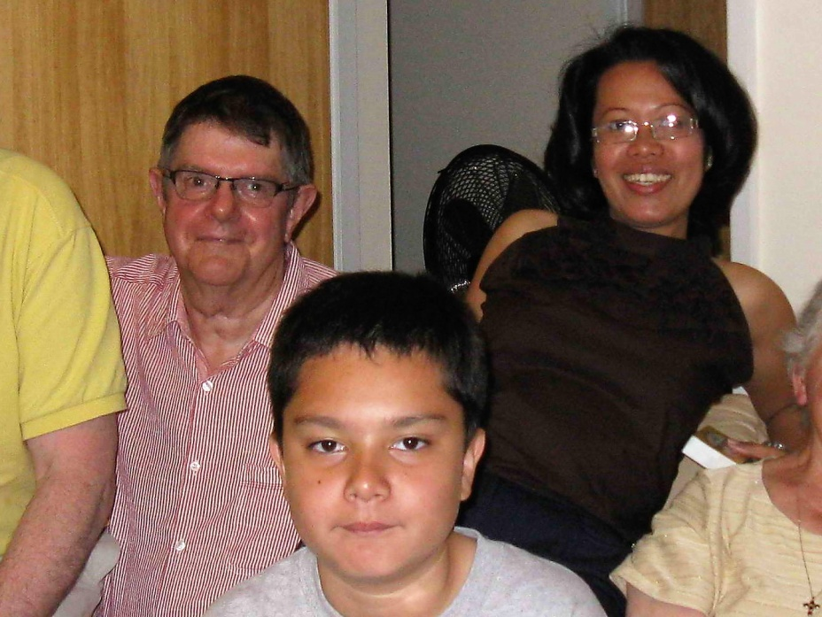his scriptures. One morning his coffee tasted terrible so he thought that maybe Leah hadn’t washed the coffee pot, so he washed it and then made a fresh batch of coffee. As he started to drink this cup of coffee, he tasted even worse than the first one, so he dumped it out, and just continued to read his scriptures. The next time we met with him, he told us about this experience and said he had been reading in the D&C section 88 where it talks about the Word of Wisdom and said “I guess I am not supposed to be drinking coffee, is that correct?” We said yes, that it is against the Word of Wisdom, and the Word of Wisdom is to keep us healthy. From that day on, he never drank another cup of coffee. We were proud of him.

Tony had a little café in Munoz and was a wonderful chef; Leah was also a great cook. We went to this café sometimes and so did the Elders who served in this area. Tony and Leah invited us to their beautiful home and prepared delicious meals for us. (Not many homes were as nice as this one in the Philippines. They also had beautiful furniture, china, etc. Tony had met Leah in Hong Gong. She is Filipino, but was working there as an entertainer. Tony was born and raised in Holland. They lived different places and bought furniture there.)

One time when they had invited us to dinner and Family Home Evening, they had invited the Elders also. As we were sitting in their living room listening to Tony give the lesson**, I saw a large rat running back and forth along the top of their entertainment center.** Ken and I were sitting on a couch, in front of the entertainment center. The Elders were sitting on a love seat at one end of the living room and Tony, Leah and Michael were sitting on a love seat on the other end of the living room. As I watched in horror at this rat, it jumped and flew across the room in the direction of the Elder’s and lit on the back of their love seat. It ran down the back of the love seat and ran along the side of the wall and into another room. The others didn’t notice the rat, Ken hadn’t either as they were focused on Tony. I was so grateful that the rat hadn’t jumped in my direction, or I would have screamed and ducked.

Tony was baptized and then given the Aaronic Priesthood and then he baptized Leah and Michael. Leah’s 17-year-old niece lived with them for a while. When I told her about the Personal Progress Program, she became excited. I gave her the book and she started working on the requirements to receive her certificate and her YW medallion. This program usually takes the girls at least 3 years to complete, but since she had to have it finished before she turned 18, she worked and studied hard, she finished all the requirements in less than a year. We were proud of her. When we returned home, we were so busy that we didn’t keep in touch with them and later we found out that Tony had been in a terrible accident and was in the hospital for a long time. He almost lost his life. He was riding his motorcycle late at night, coming home from his café, and ran into a caribou. This accident left him with many injuries and caused him to be by-polar, changing his personality. Finally, Leah couldn’t take it and she divorced Tony. We were very sad to hear that. Tony told us by way of Facebook. He was living in Norway with his daughter from an earlier marriage. He said that Leah didn’t go to church anymore, but that he was still trying to go and to read the scriptures. We were happy to hear that.

We saw other rats there as we would visit the families – some in their homes and some outside. I hated them. One time I saw a rat on top of the table in one of the homes. We were sitting in the living room, but I could see into the kitchen. The rat was trying to get into the food that was on the table, but they had covers over the food, thank goodness.

When Elder Browning and I were asked by our branch president to help him with the **Health Fair,** he took us to see the **Mayor of Munoz.** We needed to ask him if we could use a school or other venue to hold this Health Fair. When we arrived at the office of the Mayor, his waiting room was full, and we thought “Oh dear, we are going to have to wait a long time, and we don’t have a lot of time to waste.” The branch president **(find his name)** talked to the receptionist and the next thing we knew, we were invited into his office. We introduced ourselves and told him the reason for our visit. He was very gracious and made a couple of phone calls and told us that we could use the elementary school. He had talked to the principal and she would be expecting us to come and look over it and give her the details of what we would be needing. He told us if there was anything else we needed, to please come see him. He told us that he would like to come to our Health Fair too, and we were excited. This was a big project. This was supposed to be the responsibility of the District Presidency, but they handed it down to the branch presidency and they were over whelmed with it, and that’s why they asked for our help. We worked with the couple missionary who were over these health fairs to get the instructions, etc. We had many in our branch help us and together we were able to pull it off. There were displays, presentations and demonstrations. These were set up all around the outside of the front of the school. There was a nursing station where the people could get vaccinations, their blood pressure checked, a minimal physical checkup, etc. There was a program at the end of each day. This was a three-day health fair. The school children, from all the schools attended and some preformed at the programs, families attended, business and political leaders and the church leaders. It was very successful. It was stressful for Ken and I, but it was well worth it.

After this, whenever there was a cultural or entertainment event that the city put on (which was several), the mayor sent Elder Browning and I a personal invitation. We would be excited and when we went to the first one, we got there a little early, and just sat down about in the middle of the auditorium. Before long, here came the Mayor walking down to us. He told us to follow him and he lead us to the front of the auditorium and had us sit on the front row with some other dignitaries. He asked if we would help present the beautiful leis to the performers at the end of their performances. We were happy to do this, but wondered why he would want us to do this. There were camera men there taking pictures and we realized we were being pyrographed also. We worried that maybe our mission president wouldn’t want us to spend our valuable mission time going to these events and thought he might find out about it since we might be on the news. We called President Brimhall and told him about this and asked what we should do. He was excited and told us to keep attending them as it was good publicity for our church. We enjoyed these events and each time the Mayor would insist that we sit on the front row and help present the gifts or leis.

We saw other rats there as we would visit the families – some in their homes and some outside. I hated them. One time I saw a rat on top of the table in one of the homes. We were sitting in the living room, but I could see into the kitchen. The rat was trying to get into the food that was on the table, but they had covers over the food, thank goodness.

**(Tell about the mayor of Munoz here and the activities he invited us to, etc…………….( I did write it up on Nov. 25, 2017, find it).**

We have also met several special people and families while walking at the college near us, in the mornings. We are currently helping the Lord to prepare them to be taught the gospel. We have given other referrals to the Young Elders, as that is the Young Elders responsibility to teach, but we, as couple missionaries, are to help with activation, retention and mainly Leadership Training. One such couple we met while on our morning walks was the **Anywanu family.** We met **Marie** first and enjoyed visiting with her. She told us about her family, how her husband was from Africa and was here in the Philippines, at this college, getting his doctorate degree. They have these four beautiful children. She wanted us to meet them and invited us to dinner at their home. We went and had a wonderful time visiting and eating the delicious meal she prepared. She made wonderful home baked bread, and we bought loafs from her several times. We invited their family for dinner also. They are Christian and 7th Day Adventists. We discussed religion. We asked if we could show them some of our beautiful videos on the Savior and they said they could reserve a pavilion near their home and wondered if 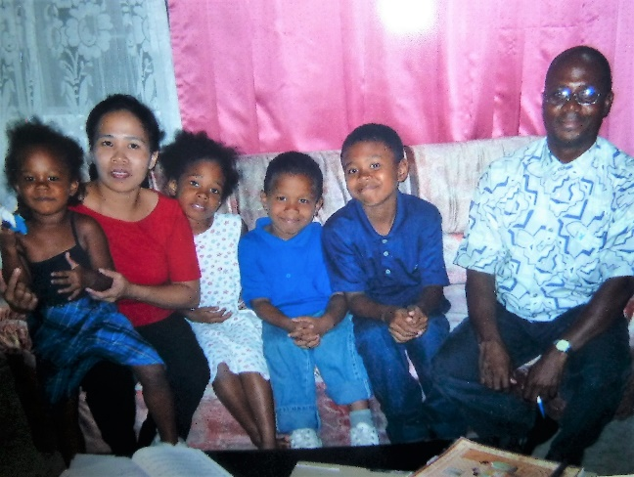they could invite their friends. We were excited and said “certainly”. We took our projector, screen and videos and I made brownies, and it was a success. Many came and were impressed with the videos and we all had a wonderful time afterwards discussing them and getting to know each other.

We have helped to prepare couples and families to go to the temple. We were privileged to go to the Manila temple and witness the temple marriages of one family and four young couples. We loved this family and all these couples, but two of them we are especially impressed with **Ronald and Crisanta Dator** and **William and Anna Liza Mactal Buccay**. Roger was single, when we met him. He lived in our branch and we had visited him and his parents and siblings. We needed some electrical work done in our home, so we hired Ronald and he did a great job. We had him do other electrical jobs for us after that. He met Crisanta, a beautiful, wonderful, spiritual young woman. They fell in love and we were privileged to teach them the temple preparation lessons and go to the Manila Temple with them when they were married for time and all eternity. It was a wonderful ceremony and a wonderful day. Ronald’s older brother married a righteous woman in the temple and they had two little children when we first met them. We hired him (can’t remember his name right now) to wash our car at least once a week. He had a trike with a sidecar and had this as his main business – like a Taxi business. Many men did that. He took our daughters, Sandi & Shellie, for a ride on his trike when they were visiting us.

We met **Anna Liza** at a YW activity as she was the District Young Women’s President. She was a beautiful, outstanding young woman with many talents and leadership ability. We were very impressed with her. She lived in Guimba and we visited her, her parents and siblings in the parent’s home. We fell in love with all of them. Her parents are such wonderful people and her sisters were beautiful and special too. William came home from his mission and he and Anna Liza started dating. They got too intimate, so had to be disfellowshipped. That was hard on them and on us. They kept coming to church faithfully, but they couldn’t take the sacrament or hold positions, so she was released from being the YW president. In time they both fully repented and were able to make plans to be married in the Manila Temple. We were privileged to work with them and teach them lessons. About that time, President Oaks was released from being our Area President as his time was up and we were sad to have him leave. President Maines was his counselor and he was sustained as the new area president. President Oaks was pretty lenient with the couple missionaries and let us go to the temple with our branch members on their branch temple trips and with these special couples who were to be married there. He also let us couples travel with each other to see various beautiful places here in the Philippines, on our “P” days or on holidays. Elder & Sister Hyer had a van and us four couples fit in it and we enjoyed these trips tremendously. President Maines stopped all that and told the mission presidents that the couples were not to travel outside our missions and that went for going to the temple also as it was in Manila and outside of our mission. When we heard that and told Anna Liza and William that we would not be able to go with them to the temple, they said that they were not going to go to the temple without us. We tried to explain to them why we couldn’t, but they were insistent that we go with them, so we talked to President Brimhall and he talked to President Maines and explained this situation, and he finally made an exception for this one time. We were thrilled and it was a beautiful day in the temple with this special couple and their family and friends**. (This picture is of them with us. They are holding the wedding gift we gave them).** We keep in touch with them through Facebook and Email and we found out that Anna Liza got her teaching degree and is teaching school. They were only able to have one child – a son, who they love very much. William was put in as branch president and later as a counselor to President Mario Gasmena in the District Presidency. She has had many positions in her branch and district. We love them.

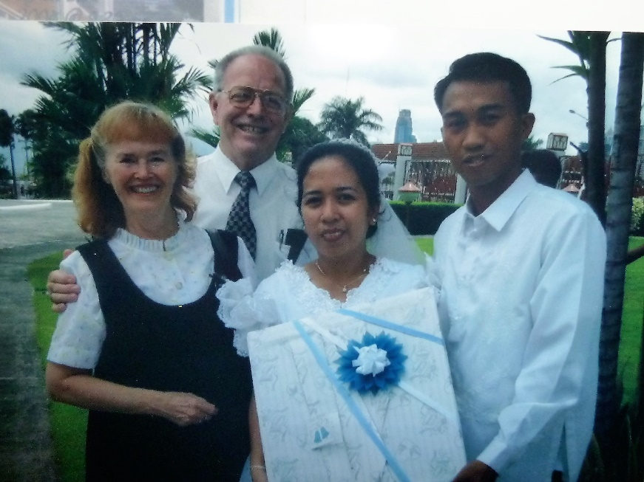 Ken and I tried to talk to Anna Liza’s parents about being sealed in the temple and then having their children sealed to them, but her father said that they didn’t have the money to pay tithing. We talked to them about having faith, paying it first and then the Lord would bless them. Anna Liza’s sisters wanted to be married in the temple and they found handsome, righteous men who they did marry in the temple. We found out later that the parents did take the leap of faith and started paying tithing, got their recommends and were sealed to each other and their family. What a happy family they are now, however, the father has had health problems and been in the hospital at times. We love this special family. Anna Liza and her sisters put pictures of them, their families and their parents with all the family together, on Facebook and we love seeing these pictures.

We were called upon to speak at many branch and district meetings and activities, sometimes at the last minute, so we are very thankful to the Lord for his help and inspiration. On two different occasions – one was a Guimba District Young Women’s conference. I was handed a program when we walked in, and my name was on the program as the main speaker. That caught me off guard as I hadn’t been asked. In fact, we had just come from the Paniqui District where we had done some training, and we almost hadn’t stopped at this YW Conference. Thankfully, the Lord blessed me again, as he did many times and I felt He put words in my mouth. I remember speaking on the Young Woman’s program, but I don’t remember what I said. Ken and others said I gave a good talk. Another time was when I went to the Guimba District primary program and activity, and again my name was on the program and I hadn’t been asked to speak.

When we went to the Paniqui District Leadership trainings, which they held once a month, President Nadado or one of his counselors would either ask us as we came in, if we would train the R.S. or Primary or YW for me, and the Elder’s Quorum and branch presidencies for Ken or sometimes, they would just announce, from the pulpit, that we would be training a certain organization or priesthood group – so we had to be prepared. I would have been really stressed if asked to do that over here, but with the Lord’s help, and “angels to bear us up”, like we were told in our priesthood blessings, we were able to do it.

We have gone through several typhoons during this year, three of which caused quite extensive damage with considerable loss to property, farm crops & lives. We had the opportunity to help render relief to many victims of these storms. We met with the district R.S. leaders and they had a check from the district president, so we went shopping. We came back and with others helping, we divided up this food (rice, sardines, crackers, medicines, etc.) into cloth sacks and went to deliver it to the families. Ken and I drove our car to different areas and then, with our boots on, we walked through the water to deliver the food, etc. We saw some sad sights. In November, there were two typhoons that caused quite extensive damage and then followed reports of a “super” typhoon that was coming in. 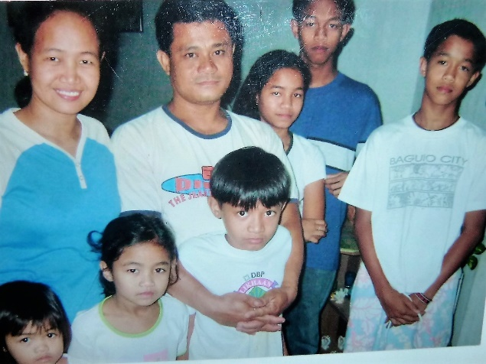There were massive preparations for this storm. However, when the storm hit, the winds stayed high, basically not touching the ground and was only 24 hours of a high wind noise, almost like the noise of jet airplanes over head.

We loved serving the Lord and serving these wonderful Filipino brothers and sisters in our two districts**. President Mercado was the district president of the Guimba District** and **President Patronilo Nadado was the president from the Paniqui District.** We grew to love and respect **President Nadado and his sweet wife** and their children, and we became good friends. They invited us to their home for dinner and I think Family Home Evening. They told us their stories of how they met and the circumstances surrounding their romance, and the trials and difficulties they faced. Theirs was such a fascinating story that I typed it up and send it in to the Ensign, hoping that it would be printed in one of the issues, but it wasn’t. The picture is of the Nadado family.

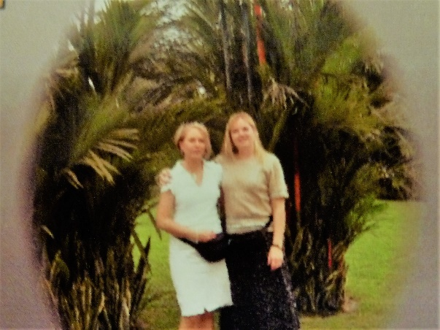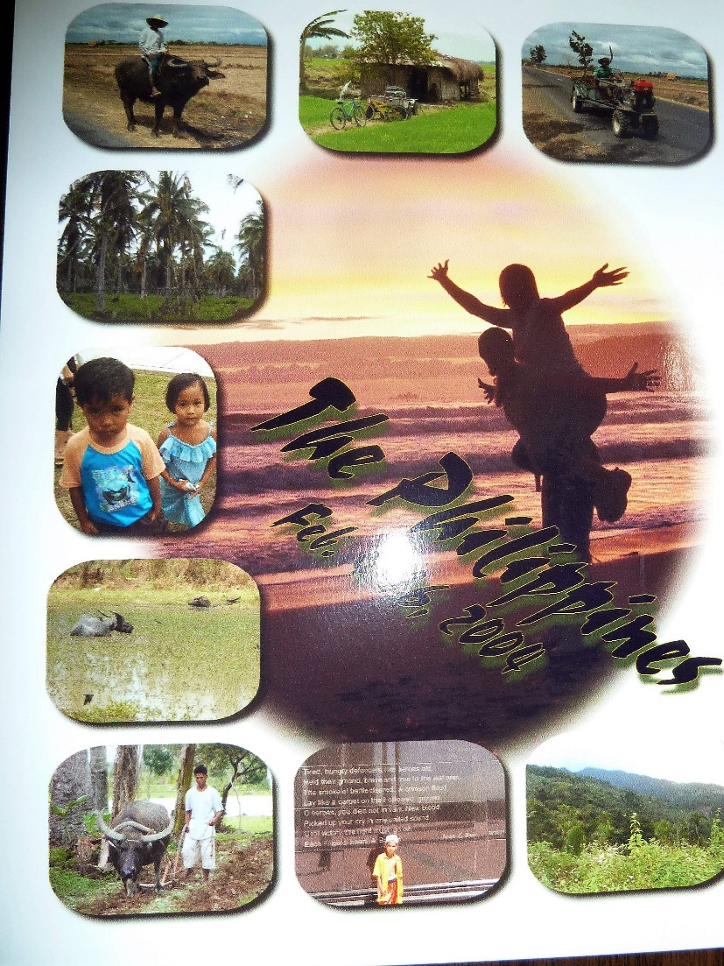 We had the opportunity of having our two daughters, **Sandi and Shellie, come to the Philippines** and spend 10 days with us in February. This opportunity came as a result of our eldest daughter’s husband (Terry) being killed in a car accident on November 21st of 2003. This was the evening of Sandi’s birthday, so what a horrible birthday that was. After counseling with our mission president, he asked that we consider remaining on our mission, rather than returning home for the funeral. His suggestion was that we have our daughter come over and spend time with us after the funeral. He said that it might be good for her to get away, relax and enjoy being with us. He said we could take time off to take her to some of the beautiful places here in the Philippines. We called Sandi, and she agreed that we shouldn’t leave our mission and that she would love to come visit us in the Philippines. As we were concerned with our daughter traveling alone, we also invited her sister, who was excited to join her.

We had a wonderful experience, of a lifetime, with them and were able to take them to see some of the beautiful sights here in the Philippines. We took them up the mountains and through the jungle to Balair. Balair is located right by the ocean and they have a beautiful resort there. When Ken and I would go there, either by ourselves, or with one of the other couples (Maharry’s or Clarks), to help the branch with their branch conference or to do trainings for them, we would stay in the beautiful motel on the sandy ocean beach. We would walk along the beach in the evenings, pick up sea shells and just enjoy looking at the ocean. We knew Sandi & Shellie would love to go there, and they did. We ate in the restaurant there at the resort, but none of us enjoyed the food too much. The girls put on their swimming suits and enjoyed playing in the ocean while Ken and I took pictures and walked along the beach.

We took them to Baguio, where we had gone with the other couples for our Easter holiday. We had stayed in the Camp John Hayes Hotel, which is really beautiful and is a resort area. Baguio has a milder climate, not as hot and humid as where we live, and most of the Philippines. It is more on the mountains and is so beautiful there. They raise lots of fruits and vegetables. There are many carving shops, jewelry shops, etc., so the girls wanted to go shopping and we spent a couple of fun, wonderful days at this hotel and in Baguio.

We also took them to another area, where we had hiked the mountain with the Clarks to a beautiful waterfall. The trail isn’t too easy as we had to climb over large boulders and logs and cross the river on makeshift bridges. Luckily, both times we went there (with the Clarks and with the girls), there were youth climbing also, and they were happy to help us. We sure appreciated them. It was fun and very beautiful there.

We went lots of places – walked over hanging bridges and took pictures of the beautiful rivers and lush, green landscapes below.

We also took them with us as we went to meetings and did some training and teaching. They were so graciously accepted by the wonderful members here in the Philippines. The children really loved them too, and Sandi & Shellie played with some children, outside, when we were in one of our meetings, and they had a great time. The children didn’t want them to quit when Sandi & Shellie got tired. We hated to take our daughters back to Manila to the airport at the end of their two-week vacation, the time had gone by so fast. We had such a great time and loved being with these special, beautiful daughters.

Unlike the young Elders, who often count their success by the number of baptisms they have had, our success is in seeing the wards and branches progressing and members excited as they fulfill and magnify their callings. It is also in watching member’s testimonies grow of the Lord, Jesus Christ as they pray, study the scriptures and keep his commandments, and to see families become active in the Church and be sealed together in the Holy Temple.

2004 has been an exciting year, filled with many wonderful, as well as challenging experiences and meeting many wonderful friends, who are our brothers and sisters in this part of the world.

**Saturday, August 07, 2004**

**Ken still has some health problems**. I think they are mainly caused by diet and **stress.** He wants to “fix” everything and he can’t fix everything over here and it is hard on him. He gets frustrated and discouraged. Sometimes I don’t help him, as I get upset with him when he gets to talking negatively, especially when he says he doesn’t think we are accomplishing anything, when I am sure we are. I tell him “I can see progress even if you can’t.” I wish he could relax more and enjoy the mission more. Satan wants Ken to get discouraged, I’m sure, as he knows how Ken wants to help these people & can help them. President and Sister Brimhall are always praising us for all we’re doing, so I tell him that the mission president thinks we’re doing great. When President Oaks left, he told the people that in ten years, he feels the Church will be flourishing in the Philippines.

**Sunday, August 29, 2004**

**I have to write about some of the special sisters in the Guimba 1st Branch who I have grown to love.**

* **Sister Iluminada Vigilia** – She is a cute older sister who just lost her husband. She is a retired school teacher, and she always looks so nice – she is slim & trim and beautiful, except for her teeth. She has one crooked tooth in front and has lost most of the others. Her hair always looks nice, she has nice clothes, even though they are probably old, she wears jewelry and nice sandals. She always looks “klassy”. I think she bought and wore these clothes when she was a school teacher. She is the chorister in Sacrament Meeting and does a great job… She told me that I am the only couple missionary sister that she has ever been close to, and that she loves me. I love her too.

She thanked me today for bringing her food during the flooding and asked if I instigated it. I told her that the District Presidency got the money from the PBO and gave it to us and we got together with President Cabuyaban and other leaders to have a meeting to decide what food we need and how many need it and who to how to disperse it. All 3 branches were affected. Elder Browning got a little impatient because they were not accomplishing much in the meeting and finally he told them to give him the money and we would take the district R.S. presidency and buy the food. They could decide who the food is to go to, but we would get it and meet other sisters at our R.S. president’s home, Sister Villanuela and package the food and then we could all take it around – which we did. I loved visiting the people as we gave it out. We went over to where 7 families were isolated and without food because the river was too deep and too wide to get across. The bridge washed out last year in a typhoon and the government won’t build a new one for them. Ken bought a rope for them and a tatay (father) on this side of the river who has family over on the other side, went into the water and tied the rope around a big tree and then swam across the river with the rest of the rope and then tied it to another big tree on the other side. This way the tatays could get back and forth across the river. We left the packages of food with the older father and he will see that his children get the food.

* **Sister Mactal’s sister** (have to find her name) She is such a sweet lady. She has a granddaughter in Japan who is an entertainer. She pulled me aside soon after we started going to this branch and said she was so worried about her granddaughter as she heard she was in trouble with the law because she was helping her boss to smuggle in other girls to be entertainers who didn’t have visa’s. She said she couldn’t eat or sleep for worrying about her. She asked me what she could do. I prayed with her and for her granddaughter and put her name in the temple. Since then, we have become close and today she told me that she heard we were to be transferred this week and asked if that was true. I told her “no”, however, Elder Browning might be released from being 1st counselor to Pres. Cabuyaban soon as Pres. Brimhall needed us to help train the leaders in other branches. She said when she heard that we would be transferred; she started to cry as she will miss me so much. I love her and will miss her also.
* **Sister Mactal** who is 74, single, retired school teacher, has 1 sister and 2 brothers who live close by. Quinciano is active and so is her sister, who she lives with, but her other brother is not a member. Sister Mactal had a stroke about 3 months ago, but is doing much better now.
* **Juliana Geronimo** – She has a hard life. She has 5 children and is struggling to feed, clothe and educate them as she husband is lazy and is just a trike driver. She tried to work for a while, and her husband realized that she was making more than he was, so he quit working. Her children missed her and got sick – both physically and emotionally, so she quit to take care of them. She is a pretty woman except for her teeth also. Many Filipino women (and men) have lost most of their teeth, or they are crooked because they cannot afford to go to a dentist. She told me yesterday when she saw me in my pants and top and my hair down, that I was “sexy”. She also told Sis. Emie, who was with me, that she wasn’t as sexy as I was and yet she is much younger. I wasn’t happy to have her do that as I could see that it made Sis. Emie feel bad. They live in a very tiny home and have “nothing” in the way of earthly possessions. She is still a cute lady, but always telling me her troubles and that she needs money. I know she does.
* **Luzuimnda De Guzman** – She is a good friend of Juliana. She also has a hard life. Her husband has been sick for several months and so doesn’t work. Not sure if he is as sick as he makes out or not – maybe he is, but most men over here are lazy. She works at a school as a custodian. She doesn’t make much money so they are struggling. She has been a member of the church for 32 years. Her mother is a temple worker at the Manila Temple. Sister De Guzman does handicrafts. I went to her house to buy some and they are very nice – klenex boxes, letter holders, purses, hats, etc. I bought most of what she had for P500. She doesn’t have the lace, ribbon and flowers to finish them up, so I paid her in advance for them so she could buy these materials – but she used the money to take her husband to the doctor and get medicine. I gave her another P200 and ordered another purse & hat, but she again used the money for food for her family. I think I will go buy the materials, take to her and then pick up the items soon. She is a nice lady. Their home is also tiny with a dirt floor. She has a darling daughter who is 10 years old and in primary. She is also a smart girl. She has 3 teenage daughters and an older son who is a drunk. She feels so bad about him. She wanted him to go on a mission and kind of blames the branch for not helping him more. He got attached to one of the missionaries and when he went home, the son went inactive and started drinking with his old friends again.
* **Luz Patrinas** – the new YW president. She was the 1st counselor to Sis. Villanueva in the R.S. Presidency. She has a 13-year-old daughter who is less-active, and a drunken husband who drinks, smokes and gambles. I saw him the night I went to her house to train her and he looked terrible. I saw him another night when he came on his motorcycle to see her at the church when we were there for mutual and to give her money for her trike fare home, and he was really handsome. What a shame. She feels so bad because she would love to be married in the temple. She has a temple recommend. She is a special lady and I am helping her with mutual until she gets her counselors and they get trained.
* **Sister Emie Baltazar** – a recent convert, but a ball of fire. She is great! She wants to help everyone and is so wonderful. She is the employment specialist and also the new 1st counselor in the primary presidency to Sister Cabuyaban. I love her. We became good friends.

She made Ken & I a beautiful large cross stitch of the Savior. We loved it, but Sister & President Brimhall had bought us a beautiful quilt made here in the Philippines, so we asked Emie if we could give it to President & Sister Brimhall and have her make another one for us. We insisted on paying her for it, even thought she had made it for us out of love. She really needed the money, so finally accepted. We had this one framed and when we gave it to President & Sister Brimhall, they were so thrilled. Emie did make us another one and we have it hanging in our living room with a light above it. It is the picture of Christ in his red robe.

We asked Emie if she could travel with us and show us some of the beautiful and fascinating places here in the Philippines before we left for home, as we were staying two weeks longer, after our mission was completed to do this. She was excited about that, and she took us to see the home of the late President of the Philippines, to other beautiful structures and places. We rode in a carriage pulled by a horse with driver in one of the towns. She took us to **100 Islands** where we rode on a special boat, manned by two brothers. They took us to several big islands, two of which we were able to explore. One had a restaurant, a CR (bathrooms) and interesting places. Another had belonged to one of the dignitaries of the Philippine government so it had beautiful home and surroundings.

Emie wasn’t able to go to other places with us, because of her work schedule, but told us of some places we should visit or activities we should do. She told us to go to **Corregidor** so we did and were able to go on a bus tour of the island. We saw the big guns that were used during the war. We went to a **volcano** where we rode practically bareback on thin, boney mules up a mountain to see inside the volcano. My behind was so sore after that ride that I was miserable. It was beautiful up there to look down from where we had come and also to look inside the volcano, but I was dreading the trip back down. We also went to **a beautiful river where you could hire men to take you in a canoe up the river to a beautiful waterfall and then back again. That was a trip of a lifetime**. The walls of the mountains were covered with green, lush bushes, ivey, etc. They told us that if we wanted to ride the raft to the waterfall and inside it, we would need to bring another change of clothes. We wanted to do this. When the Filipino men paddled the raft under the waterfall, it was like amazing – so much water falling on you and then to be inside this giant waterfall was also amazing. We rode back down the river, changed clothes and were thrilled that we had this opportunity.

* **Analiza Baccay** –Analiza Mactal & William just got married in the temple on the 18th. We were able to go with them. He is a returned missionary and they are such a sharp couple. She was the district YW president when we first got here and doing a fantastic job. They fell in love, and Satan tempted them, they fornicated and they had to be on disciplinary action for about 6 months. They had to be released from all their callings, not partake of the sacrament or function in every way, but they came faithfully and did whatever Pres. Cabuyaban asked them to do, so we were proud of them.
* **Sister Mactal – Analiza’s Mom**. She is a beautiful, wonderful, sweet lady. She had family home evening at their place and her and her husband and family are great. He has a problem with tithing, so didn’t go to the temple with Analiza and William. Ken had been really working with him to realize that if he had faith and just paid it at the first of the month when he gets his check, the Lord would bless him and he would have enough to pay his bills. Guess he still lacks faith. Hope he will gain it soon. He told us that they are working towards going to the temple.
* **Lolita Dela Cruz** – Such a sweet lady. She was a teacher in primary and is now 2nd counselor. She is very faithful and dedicated. She is good with the children. Has had many trials. She has a son who has mental problems and killed a man and intended to kill several others because they made fun of him. He was put in prison (was supposed to be an institution for the mentally retarded) Sis. Dela Cruz works hard and only makes P100 a day and it cost that much for the medication for her son. She has twin sons about 14, a daughter about 15 and older children. Her husband is not active and I’ve been told is mean to her. She is a little heavy, but so humble, sweet and childlike. I love her. About a month ago, she was given P1,000 to pay to have her son put in the institution, and to pay for his medicine. Well she spent some of it to buy soda pop for some of the guards (again, so childlike – she shouldn’t have done that as it was fast offering money, not her money. When asked by Pres. Cabuyaban why she did that, she said because she wanted to be nice to them and give them a treat) Someone robbed her wallet from her while she was riding in a jeepnie, so she was so distraught. I tried to comfort her and prayed with her, but she kept crying. She said the money wasn’t as important as the papers and cards in the wallet. Her tax card was there and she needed it along with a deed to the land where their house is, etc. I felt so bad for her. She has still been faithful to come every week to church and is still cheerful now.
* **Janet Abad, Maricel, Myra – Ex YW Presidency**. Janet is now a counselor in the R.S. Presidency. She is tall, shy, single about 28, but a special young woman. I have grown to love her and I think she does me now. It took a while, as she doesn’t speak too much English, so she would try to avoid me as much as possible, but when I was helping them with Mutual each week, she was grateful and started to smile and be friendlier.
* **Irenea Ramos** – beautiful, older, tiny lady. Has lots of health problems. Her eyes bother her a lot also. She was so sad when her brother died and cried all the time. I thought she was the wife, instead of the sister. The wife is Sister Iluminada Vigilia and was cute and smiling, so I thought she was the sister. I knew the two ladies were sister-in-laws. I found out when I went with Sister Ramos to the casket and said to her, “I’ll bet your husband was a good man.” She said “He isn’t my husband, he’s my brother”, and pointed out his wife. I was embarrassed.
* **Lulinda Villaneuva** – my special friend. She is the R.S. President. When we first arrived on our mission and visited this ward, she and I became acquainted. She was the gospel doctrine teacher at the time. She took me into an empty classroom after meetings and confided in me that she and her husband were not married, but had lived together for over 15 years. They have a son named A.J. who is 12. His birthday is the same as mine. Linda’s birthday is August 24th, she turned 55. She said they can’t get married civilly or in the temple (which she wants so much) because they were both married before and separated from their spouses. They can’t get divorces here in the Philippines, so she was so distraught. I told her I would check into it and see if there is anything that can be done. I did, and there isn’t until this government changes it’s rules or the millennium comes, as the church has to abide the laws of the land. Anyway, Linda and I became fast friends. She has told me several times, that I am the only one she can trust. That is so sad, but I have learned that this is true over here in the Philippines. You can’t even trust your best friend, which is so sad. Sure hope they turn to the Lord with all their hearts and obey his commandments, and then they will be blessed.

**Jane Mango, who was in the stake Relief Society Presidency gave us the best compliment I ever had. She says: “Christmas is near approaching! And you know what reminds of that?  It reminds me of the special couple I met here in the Philippines!  The good things you’ve done to me will never be erased at all.  They are here in my heart and no one can take it from me.    Christmas reminds me of Jesus, His love to me and to all of us.  It reminds me of you, because I have seen Him in you.   I pray that, that same countenance I have seen in you will be seen also by others, so that they will also know that indeed the church is true.” Jane and I became close friends from the time we first met**

**WAR MEMORIALS**

**On plaques at the war memorial in Manila**

* O’Lord support us all the day long until the shadows lengthen and our work is done then in thy mercy grant us a safe lodging and a holy rest and peace at the last
* Some there be which have no sepulcher their name liveth for evermore.
* Here are recorded the names of Americans who gave their lives in the service of their country and who sleep in unknown graves. 1941-1945
* Included on these rolls are the names of Philippine Scouts who shared with their American comrades in the defense and liberation of the Philippines 1941-1945.

**PROBLEMS IN THE PHILIPPINES:**

Marlynn’s, (our maid) brother has been having great trials lately. There have been robbery’s going on and he was a suspect. We’re sure he is innocent as he is a RM (“Returned Missionary “that doesn’t always mean too much, especially over here), but he was home teaching and his partner verifies that and also the people they visited, on the date that a witness said he was in Cabanatuan helping with a robbery. He was engaged to be married to a fine young woman, who is also a RM, and they were to be married in December, but a man from Tarlac, came to church today and reported to her Bishop that the girl committed fornification with him and he wanted to come and get it cleared up. He has been excommunicated as he was a missionary, but she has not confessed. She also went on a mission and lied to do so. Marlynn’s brother is very distressed, as we can imagine. He wonders why he is having such great trials.

Former city official returns from a three-year mission. **Brimhall and his wife found Philippines challenging, rewarding**

**By Nancy Needham, Correspondent**  
**August 15, 2005**

Grant Brimhall, former Thousand Oaks city manager, came limping home after living in a Third World country for the past three years. On hand to welcome him back from the Philippines this summer were his six children, their spouses, and 24 grandchildren -- seven more than when he left.

**Thursday, August 05, 2004**

**Things we want to remember about the Philippines.**

1. One is that the **leaves fall from the trees every day** so that is always a daily job, if you want your place to look nice, you have to sweep up the leaves. We feel that is a hardship that we are glad doesn’t happen at home.
2. **Very few people have a telephone**, and for those that do they have a cellular phone, which is out of range, out of charge, or out of load or you do not have a phone number for them. It is very hard to get a hold of people to take care of Church callings, make assignments and appointments. As to out of load, many buy their time or load card at P30 each. That is a very expensive way to buy because you have to use those cards within 24 hours or lose the time. We buy a P300 card and that time is good for two months.

1. **There are few families that have their own transportation.** Of those that do, it will probably be a bike, or a scooter, a motorcycle, a trike and occasionally a car. Some farmers have converted a farm implement (kulikliks) which is like a large hand garden motivator with the blades taken off and tires installed and attached to a trailer. Farm implements do not have to be licensed and taxed as are other forms of transportation. Public transportation is “Trikes” which is a small motorcycle with side car. These are everywhere and often a cause of traffic blockages. There are “Jeepnies” which is a model of the old army jeep with a long body and is built to accommodate 10 to 12 people but you often see 14 to 18 and sometimes we have seen as many as 6 to 12 people hanging on the top and rear bumper. Busses are used for long distance travel and are mainly found only on major highways. Because they are large the driver often is rude and pushes the right of way. We see many motorcycle operators with helmets, often hanging from their arm. If there more that on person on a motorcycle and the operator has a helmet his passengers will not. Often you see babies, 6 months old and up riding in front between the father’s knees. We often see 3 to 4 passengers on a motorcycle.
2. We see **termite hills** everywhere, some as high as 5 and 6 feet. Once a colony gets started the people are superstitious about removing them. We saw one that had to be removed in order to put underground utilities in. After covering up the utilities the ground was raked down and a funeral was held with the placement of a cross, flowers and candles burned through the night.

1. In the eyes of North Americans, **the Filipino people are polite in some ways and rude in other ways.** For example, when you are talking with them and they need to go, they will say “please excuse me, I need to go now.” If someone comes over to talk to them, they don’t just walk away from you or turn away from you, they say “Please excuse me”. If two people are talking and blocking the hallway or doorway, etc., and a person needs to go in front of them, they will crouch down, put their hands together and say “please excuse me” or “cuse me”. But, if they are in meetings, many thinks nothing of talking to other people while someone is speaking from the pulpit or a teacher is in front teaching a class. They also think nothing of getting up and walking out – whether to go to the bathroom, to txt someone, or just walk outside for a few minutes. Adults as well as children and youth, do this. We are trying to teach them reverence and that this is also rude. They are also rude on the roads and in traffic. They walk, drive or stop anywhere or anytime they want, and they are not concerned about how it affects other people.
2. **Most Filipino people are friendly and hospitable**. Many want to give you mariandas, even though they cannot afford to do so.
3. **Many Filipino people are hardworking and industrious, but most are lazy**. Most Filipinos live in poverty. Some live-in poverty because of laziness, others because of drinking, smoking and gambling, and others because of their circumstances and upbringing.

**Sandi and Val Petersen,** my former boss, along with her husband, from Staff Development at the district came to our Sacrament Meeting where Ken and I reported our mission. After the meeting, I spoke to Sandi and she encouraged me to come back and work again at the district. She said she had just the position for me. I wondered if it was to be her secretary again. She is the Assistant Superintendent. I declined as I really want to have time now to enjoy my family and have time to visit and travel, etc. Now, in retrospect, maybe I should have gone back to work for her, as we would have been in better shape, financially.

**2005**

The past two years we were on a mission to the Philippines. Our special primary, from our home ward, sent us a 6’ green paper Christmas tree with all kinds of paper ornaments, stars, candy canes & presents, taped to the tree. These items had messages and names from the primary children, their teachers and the presidency. We taped it to our living room wall and left it up all year so we could enjoy it.

The Filipino people celebrate Christmas a little differently than we do. They start celebrating in September and end the 30th of December – they celebrate all during the “ber” months. They start playing Christmas music, putting up their lights and other decorations, and come caroling right after the 1st of September. Many children and youth come caroling, but they don’t just do it as a service or something fun to do, they expect to be paid. That is the main time in the year that these children can get some pesos. If you give them treats besides the money, they are really excited. In one town, most of the people make beautiful Christmas lanterns during the year and in September; they put up lots of little shops on both sides of the road for about a mile. These shops are made very simple, out of bamboo poles, and at night they turn the lanterns on and they are so beautiful. We loved going to meetings and trainings in Paniqui at night, as we would go through this town and see these beautiful lights. The people don’t have much money, they are a very poor people, but they love to have parties at this time of year. For their branch Christmas parties, they would plan the party for 1 pm at the church, but they were always at least ½ hour to 3 hours late starting as the people always come late. They would play games, have a program with lots of entertainment and eat a simple meal. Their parties would last several hours. The weather was always hot in the Philippines, so it didn’t seem like Christmas, but we loved celebrating with them. Last Christmas, most of the members of our “home” branch came Christmas caroling to our home. They had guitars and beautiful voices – we loved it.

The Philippines is beautiful and lush in many parts of this country. There are beautiful jungles, the ocean with white sandy beaches and also rock beaches, and beautiful green rice fields. But it is dirty; it could be a paradise if it was taken care of and improved. They have open sewers, rivers with garbage floating on top and very polluted. Because the water is so polluted, we had to carry a small plastic bottle of alcohol to use to clean our hands often. The alcohol was given to us when we were at the mission home after we arrived. The alcohol didn’t dry our hands out because it is so humid there. We had water coolers in our missionary homes and water was delivered to us in 3-gallon bottles. The plant in Munoz was very clean and sterile, so we were thankful for that. We had to take deworming pills to try to kill the parasites. The public CRs (comfort rooms – bathrooms) were so dirty, it made us sick to have to use them. Few had toilet seats and you didn’t want to sit on them anyway, so we would just squat over them. In some CRs there was just a hole in the cement. There usually weren’t any toilet paper, soap, or paper towels, so we carried Kleenex and alcohol with us. There were nicer CRs in McDonalds restaurants and some gas stations. The CRs were terrible in most hospitals. Ken found that out when he took a blind man there. We helped take supplies and equipment, with the humanitarian couple missionaries to a hospital in Guimba, and because of that, they let us take young men who wanted to go on missions there, to get a physical and their dental work done. It was horrible. We saw the dentist drop her pick, whip it off on her dirty apron and put it in the mouth of one of our to-be-missionaries. He did get an antibiotic and Ken told him to take every single pill. They did have a couple of beautiful hotels and hospitals in Manila, and the missionaries were taken there when they had to go to a hospital. Most doctors and nurses who work there were trained in the United States.

In the Philippines, there is the richest of the rich and the poorest of the poor. Most Filipinos would love to come and live in America and that is their dream. Catholic, Iglesio Cristo and our church are the religions in the Philippine Islands. Iglesio Cristo is mainly a mafia because the people have to pay every time they come to church and they must come often. They are promised protection for their money. They do dress very nicely when they come to this church. Anyone can preach or teach in this church.

There are many different types of homes is in the Philippines. Some are made of bamboo and are small, others are made of rough cement with dirt floors and hardly any furniture or belongings. Many are just shacks made out of whatever they can find – tin, cardboard, odd shaped boards, etc. It is a very poor country, but most of the people are good and sweet, hospitable and affectionate, especially the ladies and children, as most of the men drink, smoke, gamble and are lazy. Many cannot find work, if they want to work, although the tradition is that the women work. The oldest girl in the family is to support the family. Many times, she goes abroad as a house helper, nanny or entertainer. Some go to Hong Kong where they are entertainers (prostitutes). Some go to England, many go to Iran or Irack, some go to Canada and the lucky ones go to the United States. They send the money home to their families. The government takes a big hunk out of what they send home. One couple in Munoz, who we loved and were richer than most, was because the wife went to Iran and taught in a hospital there. She was a nurse and sent home the money. They saved it so their children could go to college. One daughter became a doctor and the other a nurse. The son didn’t want to go to college. The father raised the children while the mother was away making money. She could come home every few years. Their daughter, the doctor, helped us in different ways. The Filipinos are very childlike. When we were teaching or training them, we had to keep changing our way of thinking and our presentations to make them simpler, so the members could understand what we were trying to teach them. They love to have their pictures taken, so we would take pictures of them with our digital camera and then put them in our Power Point Presentation, and they loved that. That would get their attention.

There were many beggars there. Some came door to door. We had several come to our home. Others had their children beg at McDonalds, stores and where ever. The dad would have the children give him the money and then he would usually buy beer or cigarettes. When we saw these children, we would buy hamburgers for them and see that they ate it, and they were so happy as they were hungry.

Many sold wares in the middle of busy traffic. Some men drove “Trikes” which are motorcycles with a side car. They drive people around for money. That’s how some make their living. You could see a man with his small child on his lap, while driving and one or two behind him on the seat. Several would be in the side car, but it was only room enough for Ken & I. We had our own car, but we rode in one a couple of times. You could see one on top of the side car as it had a canvas top, and maybe another standing on the back. They had several accidents and you can see why. One branch president drove a trike for his living and Ken was talking to him and asked him about the number of people they can put in a Trike as it looks like it is dangerous and the president said “Yes, if you get more than 11 or 12 on a Trike, it can be dangerous. The other main types of transportation were “Jeepnies” which were jeeps made into kind of a small bus, with benches on both sides. You could get in and others would keep getting in and you would be swashed. They also had buses and some rode on top of the buses. The traffic was terrible and you would have vehicles drive on sidewalks and three across where there should be one or two. There were trucks too and you had to get out of their way as since they were bigger, they figured they had the right of way. There wasn’t much law enforcement. While Ken and I were sitting on the top floor of a Jolly Bee restaurant, we looked down on the intersection in which five streets entered the intersection. This was in San Jose. We got quite a kick out of a police officer trying to direct traffic, but most didn’t pay attention to him. One day we were there and were watching him, but when he came out into the intersection, he had a pair of gloves on. One glove painted red and the other painted green. We presume he thought this way he could control the traffic, but in reality, it wasn’t working. We also watched people get onto one of their Jeepnies and we counted over 20 people that got on that vehicle, which would be crowded for a dozen. All the banks and most businesses had an armed guard at the door with a loaded shotgun and pistols. They had the Gadeantan Robbers and the Philippines National Police. You got out of their way.

The women crouched down on their laurels (to put their feet on the cement and sit on their heels) to do their laundry by hand in a cement enclosure. They hung their clothes on the fences or wherever they could find a place. Most did iron everything, at least our Marlin did. She even ironed our sheets, garments and socks. Most of the people looked clean and neat, and the school uniforms looked great. We would see men waiting for a bus or Jeepnie and they would be sitting on their laurels. It looked so funny, we thought they looked like magpies sitting on a fence.

During planting of the palay (rice), the fields were flooded with water and they did use a mixer that looked much like our snow blowers, but had barrels that were made out of iron strips. This would work as a mixer to mix the water and the soil together, and when the field was ready for planting, the mud would be up to the knees of the planters. Large batches of pre-started seed would be given to the planter and he/she would take each stem out, one by one, and plant it until just about an inch remained above the surface of the mud. As the palay was put into the mud, each person would take an area about 3’ wide, and as fast as they could plant the starters in the mud in front of them, they would back up, and when they finished, the entire field would look like it had been planted with a transit. The plants would be in perfect straight lines going forward, sideways and on a 45-degree angle. We talked to an 80-year-old sister who said it was so hard for her to do this work, but she had no other income. They earn about 50 Pecos a day for a 10-hour day. They got two breaks, and if they cannot keep that pace up, they could get out of the field as there were more to take their place.

We were surprised when they told us the branch was having an activity at the church and it would start at 6 pm. It rarely started for one to two hours later. They were usually always late arriving and starting meetings and activities. That was hard for us. When Ken was the counselor to Branch President Cabayaban, he worked on him to start his meetings on time.

We had a beautiful home in Munoz with a gated block fence all around. We did have power outages at times and since we only had a window air conditioner in our bedroom, we would drive someplace in our car to cool off as it had air conditioning. Also, when the power went off, we didn’t have water to take showers, etc.

We loved the fruit, especially the mangos and we had a large fruit bowl with all kinds of fruit in it that we enjoyed. When we were at the mission home, soon after we arrived in the Philippines, Elder & Sister Clark invited us for breakfast and they fixed pancakes with almond butter and lots of fruit on top. It was delicious and so we have almond butter and fruit on all our waffles, pancakes and French toast.

While we were on our mission, two more grandchildren were born. **Mike and Becky had a daughter, which they named Jessica, and David & Shauna had a son, which they named Connor**. We were excited to see them, as well as all our other grandchildren and their parents, when we arrived home. I’m sure that most of you already know that **we also had a death in our family while we were gone. Sandi’s husband, Terry, was killed in a vehicle accident in November 2003. That was surely sad news for us, and it was hard for us not to leave our mission and come home to be with Sandi during this hard time**. Our mission president said it was his wish that we would stay and then have Sandi come to the Philippines a little later and spend some one-on-one time with us. She brought her sister, Shellie, and came for 10 days the following February, and we were able to show them some of the beautiful places in the Philippines as well as meet many of our wonderful Filipino friends. We had a special time together. We arrived home, from our mission, the 17th of February and since that time we have had many wonderful family get-to-gethers as well as visiting our good friends again.